README

<?xml version="1.0"?><DocumentBlank xmlns:xsi="http://www.w3.org/2001/XMLSchema-instance" xmlns:xsd="http://www.w3.org/2001/XMLSchema"> <GraphicCharterDefinitionId>0</GraphicCharterDefinitionId> <TemplateBaseTypeId>0</TemplateBaseTypeId> <CompanyId>2</CompanyId> <ConfidentialId>0</ConfidentialId> <ConfidentialDescription /> <CountryId>0</CountryId> <PageSizeId>1</PageSizeId> <PageOrientationId>1</PageOrientationId> <PrePrintedStationary>false</PrePrintedStationary> <Project>readme</Project> <Reference>20150812-110859-DT</Reference> <TemplateType>1</TemplateType> <CultureId>en-US</CultureId> <LanguageId>8</LanguageId> <Customer>NPA</Customer> <DocumentDate>2016-07-12T17:57:59.1025166+05:30</DocumentDate> <Saved>false</Saved> <IsValid>true</IsValid> <FirstPageCover>false</FirstPageCover> <IsNew>false</IsNew> <FirstPageHeader /> <FirstPageSubHeader /> <Title>README</Title></DocumentBlank>

|  |  |  |  |  |
| --- | --- | --- | --- | --- |
|  |  |  |  | |
|  |  |  |  | |
|  |  | 509v01 Modification | | |
|  |  |  | | |
|  |  | Version 1.0 of Tuesday, July 12, 2016 | | |
|  |  |  | |  |

To

|  |  |
| --- | --- |
|  |  |

Document History

|  |  |  |  |  |
| --- | --- | --- | --- | --- |
| **Version** | **Date** | **Update Origin** | **Written by** | **Verified by** |
| 1.00 | 11/07/2016 | Creation | Shikha Bansal |  |
|  |  |  |  |  |
|  |  |  |  |  |

Summary

1. Introduction 4

2. Prerequisite 4

3. Steps 4

4. Validation 15

5. Rollback 15

# Introduction

The purpose of this document is to reflect the changes made in 509v01 flat and xml bdoc and mapping(i.e. flat to xml, xml to flat mapping ).

# Prerequisite

1. Take backup of both bdocs ( M509_01_plat and Message509_01)
2. Take backup of map broker (3_b_509_01_plat_vers_xml and 3_b_509_01_xml_vers_plat).

# Steps

* **For M509_01_plat bdoc**

1. Move field MSG-LIE-SIN to 42nd position using upward arrow button.

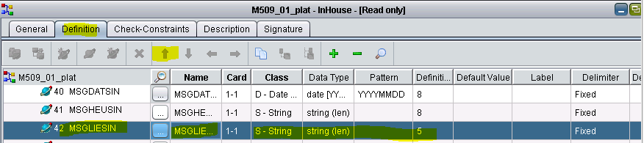

1. Move field MSG-VIL-SIN to 43rd position using upward arrow button.

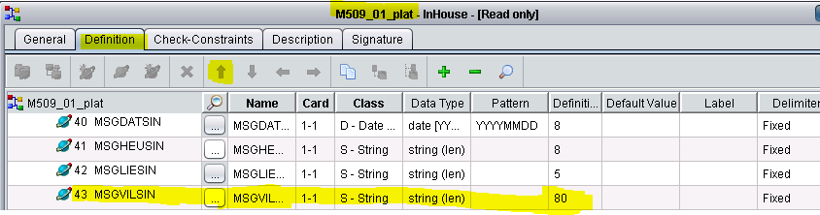

1. Move field MSG-PAY-SIN to 44nd position using upward arrow button.

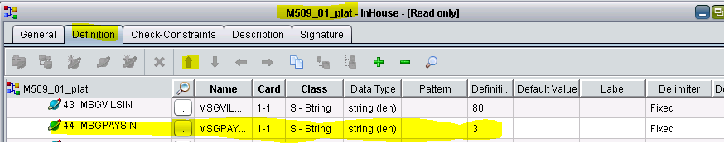

1. Move field MSG-EVE-SIN to 45nd position using upward arrow button.

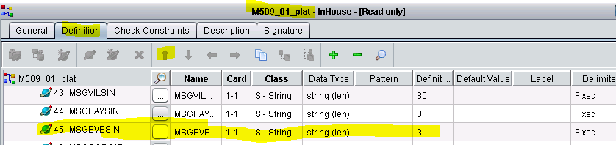

1. Move field MSG-LIE-SIN to 46nd position using upward arrow button.

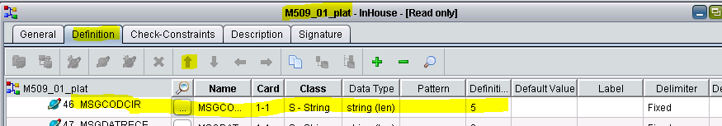

1. Change name of MSG-DAT-RECEP to MSG-DAT-RECEP.

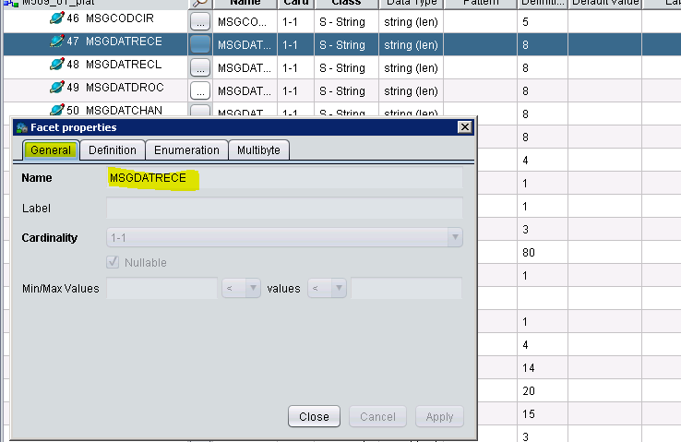

1. Change name of MSG-DAT-DOC to MSG-DAT-DROC.

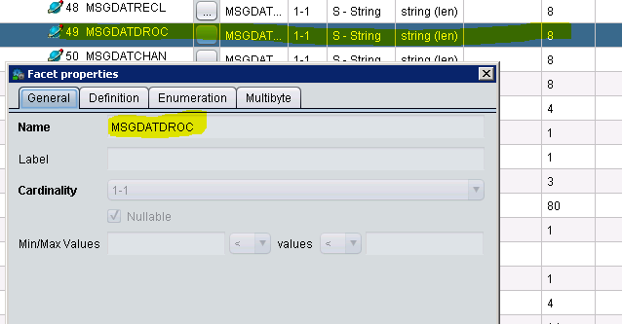

1. Change name of INT-REF-Dossier to INT-REF-DOS.

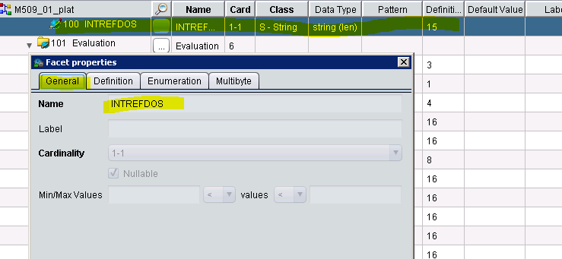

1. Convert the field type from “Integer” to “String” type of the following mentioned fields and check the “Nullable” checkbox.

1. ADVNUMVOIE 2. ADVCODPOST

3. MSGCIEADV 4. MSGINTNB

5. INTNUMVOIE 6. INTCODPOST

7. INTTEL 8. INTNUMFAX

9. MSGEVACIE 10. MSGEVABAA

11. MSGREGCIE 12. MSGREGBAA

13. MSGRECCIE 14. MSGRECBAA

15. MSGMNTFRA 16. MSGGESREG

17. MSGGESREC

**\*\* NOTE: On changing the type the length gets changed to its default value so make sure to make the changes to the value of the as before.**

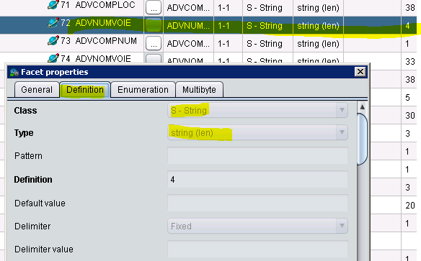

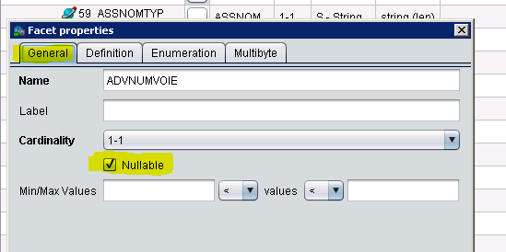

1. Convert the field type from “Date” to “String” type of the following mentioned fields and check the “Nullable” checkbox.

* MSGOUVCIE
* MSGCLOCIE
* MSGHEUSIN
* MSGDATRECE
* MSGDATRECL
* MSGDATDROC
* MSGDATCHAN
* MSGDATPRES
* MSGEVADATE
* MSGPREREG

**\*\* NOTE: On changing the type the length gets changed to its default value so make sure to make the changes to the value of the as before.**

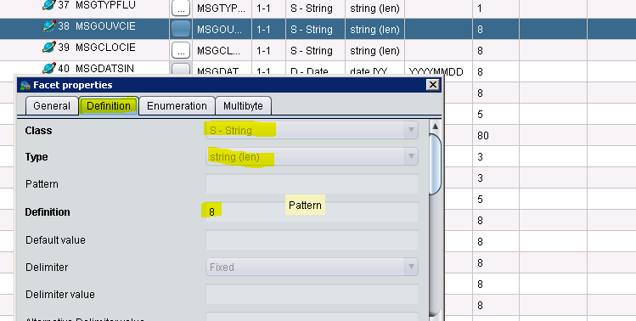

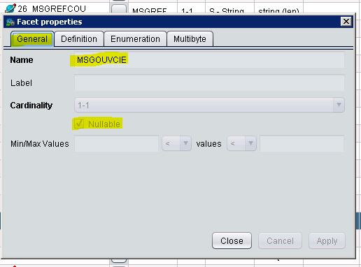

1. Convert the field type from “Real” to “Integer” type of the following mentioned fields.

MSGTAUCOU

MSGQUOPAR

**\*\* NOTE: On changing the type the length gets changed to its default value so make sure to make the changes to the value of the as before.**

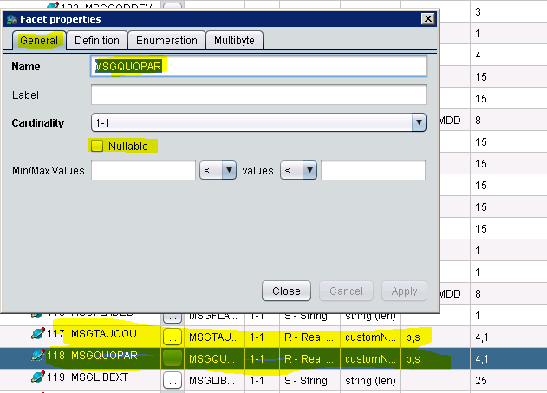

1. Change the settings in all the fields mentioned below

1. MSGNUMSEQ 2. MSGCODGES

3. MSGEXEASS 4. ASSNOMTYP

5. ASSNOMTYP 6. MSGNBRADV

7. MSGTAUCOU 8. MSGQUOPAR

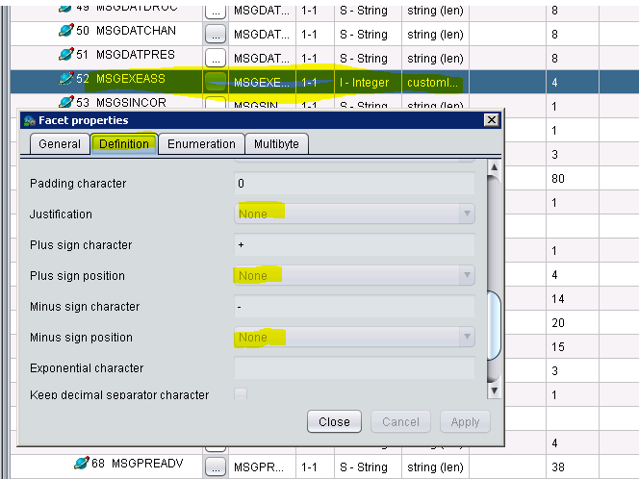

1. Check the “Nullable” checkbox for MSG-COD-DEV field.

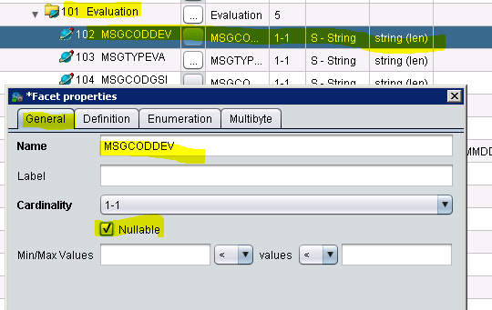

* **For Message509_01 -XML**

1. Change the name of ASS-SIGLE to SIGLE.

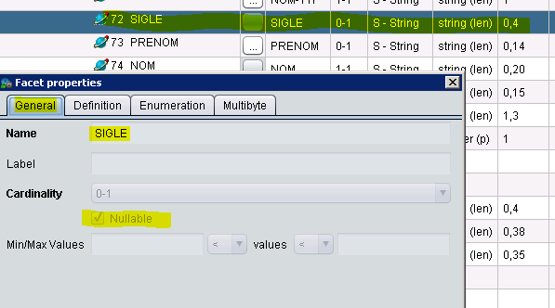

1. Change the name of ASS-NOM-TYPE to NOM-TYPE

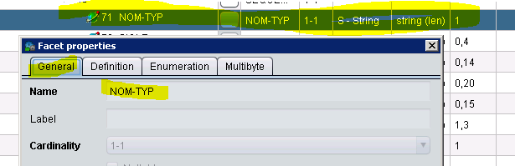

1. Change the name of ASS-NOM-TYPE to NOM-TYPE.

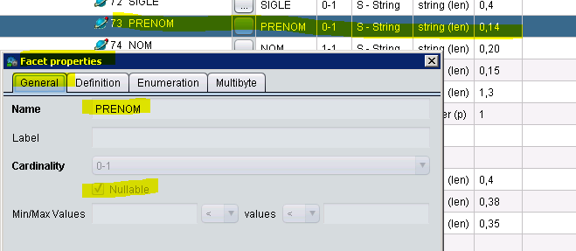

1. Change the name of ASS-NOM to NOM

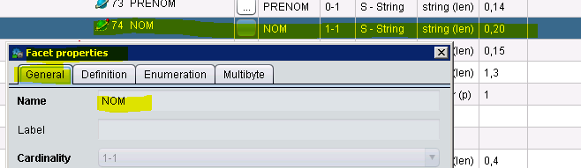

1. Check “Nullable” checkbox for all the mentioned fields below.

MSG-REF-CIE MSG-REF-COU

MSG-NUM-POL2 MSG-NUM-ADH

MSG-NUM-SIN MSG-COD-GES

MSG-GES-COU MSG-GES-CIE

MSG-OUV-COU MSG-CLO-COU

MSG-OUV-CIE MSG-CLO-CIE

MSG-HEU-SIN MSG-VIL-SIN

MSG-EVE-SIN MSG-DAT-RECE

MSG-DAT-RECL MSG-DAT-DROC

MSG-DAT-CHAN MSG-DAT-PRES

MSG-EXE-ASS MSG-SIN-CTX

MSG-CON-SIN MSG-FIL-SIN

MSG-ETA-SIN SIGLE

PRENOM MSG-ENT-CLI

MSG-NBR-ADV MSG-SIG-ADV

MSG-PRE-ADV MSG-NOM-ADV

MSG-PAY-ADV MSG-ADV-ETR

MSG-ADV-ETAT MSG-CIE-ADV

MSG-POL-ADV MSG-COD-INT

MSG-NOM-INT INT-TEL

INT-MAIL INT-NUM-FAX

INT-REF-DOS MSG-COD-DEV

MSG-TYP-EVA MSG-COD-GSI

MSG-EVA-CIE MSG-EVA-BAA

MSG-EVA-DATE MSG-REG-CIE

MSG-REG-BAA MSG-REC-CIE

MSG-REC-BAA MSG-MNT-FRA

MSG-GES-REG MSG-GES-REG

MSG-PRE-REG MSG-FLA-DEB

MSG-TAU-COU MSG-QUO-PAR

MSG-LIB-EXT MSG-LIB-EXT1

MSG-LIB-CON

**NOTE: Replace the above highlighted field name by the name of the field for which we are applying the changes.

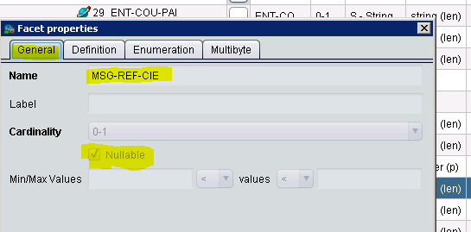

1. Change the cardinality of Evaluation from 0-5 to 0-6.

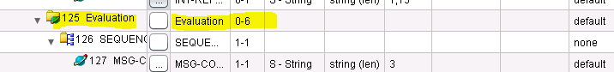

* **For mapping mr_conversion_509_plat_vers_xml**

1. Change the mapping for ENT-DAT-DEB and write in Expression

formatString( in:\Enreg100\ENTDATDEB , "YYYYMMDD")

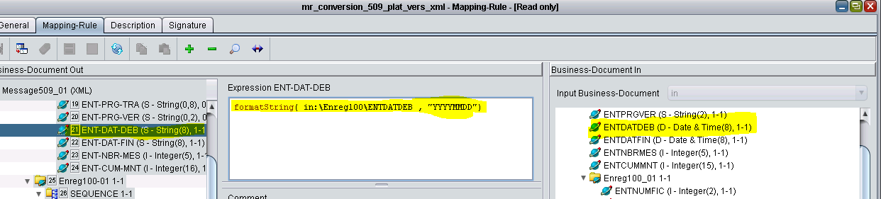

1. Change the mapping of all the fields mentioned below.

if not isNullOrAbsent(in:MSGREFCIE)

then

in:MSGREFCIE

else absent

**NOTE: Replace the above highlighted field name by the name of the field for which we are applying the changes.

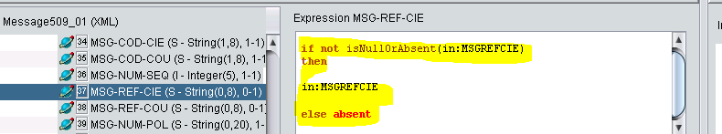

MSGREFCIE MSGREFCOU

MSGNUMPOL2 MSGNUMADH

MSGNUMSIN MSGCODGES

MSGGESCOU MSGGESCIE

MSGOUVCOU MSGCLOCOU

MSGVILSIN MSGEVESIN

MSGDATRECE MSGDATRECL

MSGDATDROC MSGDATCHAN

MSGEXEASS MSGSINCTX

MSGCONSIN MSGFILSIN

MSGETASIN SIGLE

PRENOM MSGENTCLI

MSGNBRADV MSGSIGADV

MSGPREADV MSGNOMADV

ADVCOMPLOC ADVCOMPNUM

ADVNOMVOIE ADVBURDIST

ADVLOC MSGPAYADV

MSGADVETR MSGADVETAT

MSGPOLADV MSGCODINT

MSGNOMINT INTCOMPIDE

INTCOMPLOC INTCOMPNUM

INTNOMVOIE INTBURDIST

INTLOC INTPAYS

INTMAIL INTREFDOS

MSGCODDEV MSGTYPEVA

MSGCODGSI MSGEVADATE

MSGGESREG MSGPREREG

MSGFLADEB MSGTAUCOU

MSGQUOPAR MSGLIBEXT

MSGLIBEXT1 MSGLIBCON

1. Change the mapping of all the fields mentioned below.

if not isNullOrAbsent(in:MSGOUVCIE)

then

convertToD( in:MSGOUVCIE )

else absent

**NOTE: Replace the above highlighted field name by the name of the field for which we are applying the changes.

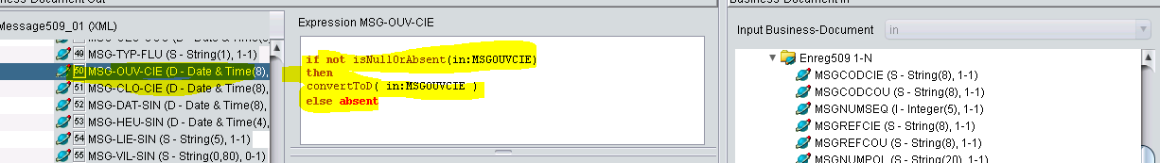

MSGOUVCIE

MSGCLOCIE

MSGHEUSIN

MSGDATPRES

1. Change the mapping of all the fields mentioned below.

if not isNullOrAbsent(in:ADVNUMVOIE)

then

convertToI( in:ADVNUMVOIE )

else absent

**NOTE: Replace the above highlighted field name by the name of the field for which we are applying the changes.

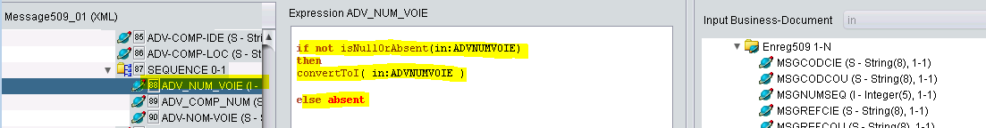

ADVNUMVOIE

ADVCODPOST

MSGCIEADV

INTNUMVOIE

INTCODPOST

INTTEL

INTNUMFAX

MSGEVACIE

MSGEVABAA

MSGREGCIE

MSGREGBAA

MSGRECCIE

MSGRECBAA

MSGMNTFRA

MSGPREREG

1. Change the mapping of MSGINTNB field mentioned below.

convertToI( in:MSGINTNB )

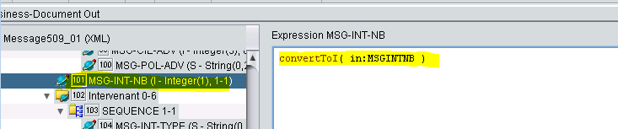

* **For mapping mr_conversion_509_plat_vers_xml**

1. Change the mapping of ENT-DAT-DEB.

convertToD( in:\Message509\Enreg100[1]\!ENT-DAT-DEB!)

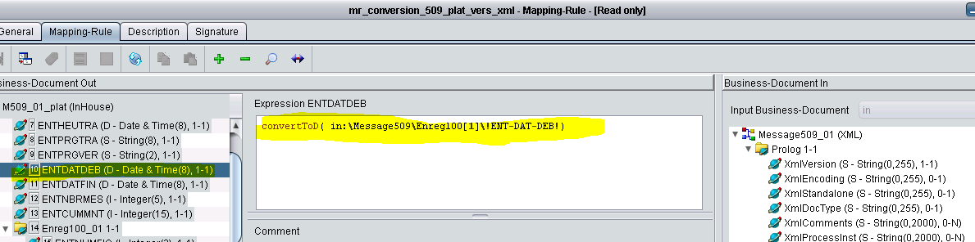

1. Change the mapping for all the fields mentioned below.

convertToI(in:!MSG-COD-GES!)

**NOTE: Replace the above highlighted field name by the name of the field for which we are applying the changes.

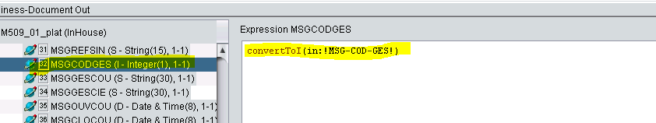

MSG-COD-GES

MSG-EXE-ASS

NOM-TYP

NOM

MSG-TAU-COU

MSG-QUO-PAR

# Validation





# Rollback

We can revert the changes from the backup steps performed during prerequisite.